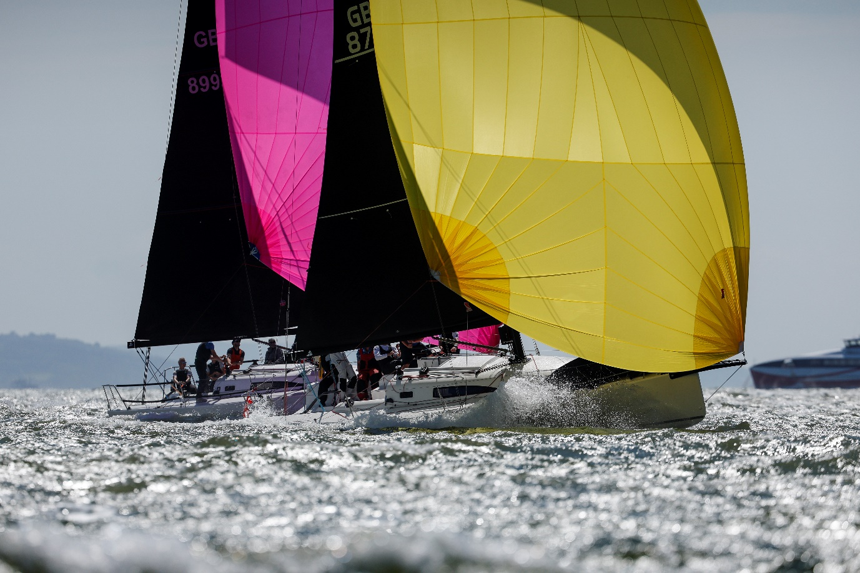

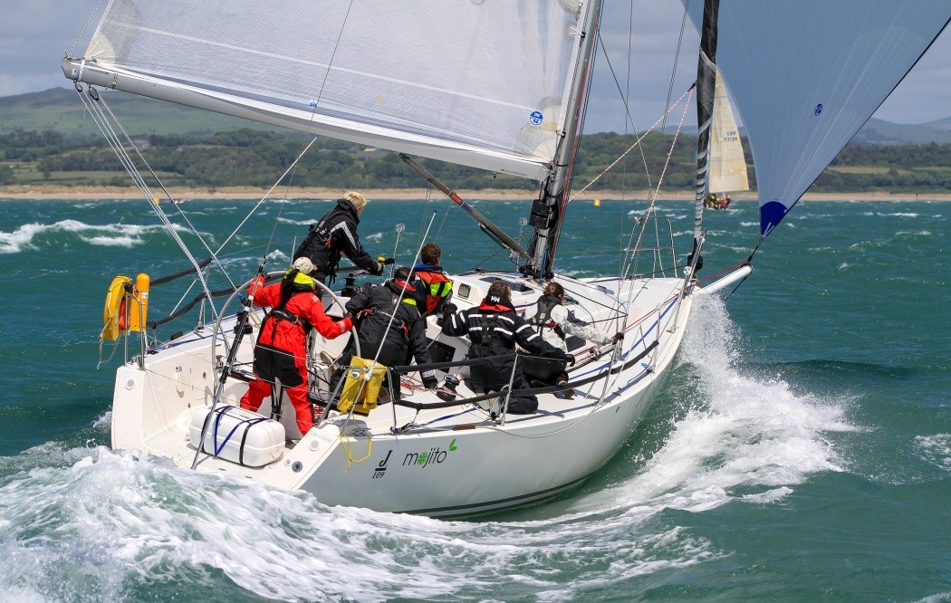
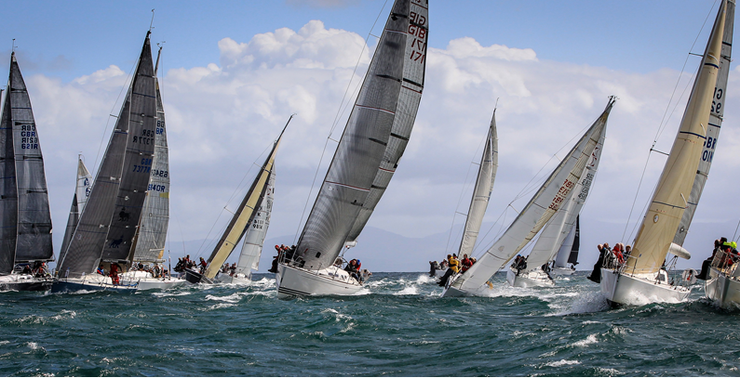



Abersoch Keelboat Week
17th – 22nd August 2025
Notice of Race

INTRODUCTION
South Caernarvonshire Yacht Club (SCYC) is delighted to be organising and hosting Abersoch Keelboat Week in 2024 which is an open event, sponsored by One Sails GBR (South) Ltd.
Keelboat Week has been an established event in the calendar for over 40 years and is renowned as being a fun regatta with a serious edge - a relaxed atmosphere off the water compliments the competition on it.
SCYC offers stunning views of Cardigan Bay, Snowdonia and the Llyn Peninsula; the waters are pristine, there is no commercial traffic and tides, such as they are, are fair. For families ashore, the beaches offer clean sand with warm and clear waters - on calm days you may even see dolphins playing close inshore. Abersoch village offers a wide variety of shops, bars and restaurants and there are many other attractions in the surrounding countryside.
Keelboat Week 2025 - Summary.
Waterside:
- IRC (IRC1, IRC2)
- White Sails (Non Spinnaker) fleet. The YTC system will be used to score results.
- Small Keelboats (Maximum LOA max circa 23 feet), to include eg Sonata, Limbo 6.6, Beneteau 211/21.7, Pandoras & Squibs. The YTC system will be used to score results.
- IRC classes will race “offshore” with committee boat starts whilst the other classes will race inshore using SCYC Club marks using either club or committee boat starts.
- Sunday 17th August will be a practice day.
- A limited number of moorings will be available to visiting yachts, free of charge – book early to avoid disappointment!
Shoreside:
- The Cove restaurant will be available for competitors who should make their own reservations throughout the week. Daily prizing-giving will be held in the bar with entertainment and light bites A closing party with live music from the fantastic “Junction 12” band will be arranged for the Friday evening.
We look forward to welcoming you to this fantastic event and will do all we can to ensure that you have a memorable and enjoyable week ……. And some great sailing!

- organising authority
- The Event is organised by and sailed under the burgee of South Caernarvonshire Yacht Club (SCYC) Abersoch, in the waters of Tremadog Bay, Admiralty Chart 1971.
- Rules
- The Event will be governed by the rules as defined in the Racing Rules of Sailing and the IRC rules, except as any of these are altered by this Notice of Race and the Sailing Instructions.
- RRS52 is amended for White Sails’ class to the extent that powered winches or other sail or rig handling equipment may be used by all boats in the class.
- IRC Rule 22.4 shall not apply. There will be no limitation on crew numbers or weight.
- Advertising
- Boats may be required to display advertising chosen and supplied by the Organising Authority.
- In participating in this event a competitor expressly grants the right for Organising Authority and any sponsors.
- Eligibility and Classes
- The Regatta is open to all boats and Classes listed below and to any other Classes accepted by the OA.
- IRC will be divided into IRC1, IRC2.
- White Sails (Non Spinnaker) - foresails must be attached to the forestay meaning that Spinnakers, Cruising chutes, Bloopers and Gennakers will not be allowed.
- Small Keelboats (Maximum LOA circa 23 feet, to include e.g. Beneteau 21.7, Pandoras, Squibs).
- Final class splits will not be decided until all entries are in.
- Depending on the number of entries, the OA reserves the right to, merge or subdivide any class, combine the starts of classes, or cancel racing for any class.
- A minimum entry of 4 boats per class is required for a start. Consideration will be given to entries from other classes to those listed above, subject to a minimum entry of 4 boats from such a class or at the discretion of the OA.
- Schedule of Races
- Sunday 17th August will be a practice race day. The practice race will not form part of the race series.
- There will be racing for all classes each day from Monday 18th to Friday 22nd August 2024
- IRC classes will race Offshore - The type of racing may be chosen from Windward/Leeward, Triangle and “round the cans” courses within Tremadog Bay.
- All other classes will race using SCYC Club marks.
- A coastal race may be added to the programme.
- Scoring System
- There will be a maximum of 10 races for all IRC classes.
- There will be a maximum of 10 races for the Small Keelboats class.
- There will be a maximum of 6 races for all other classes.
- 3 races will constitute a series in all classes.
- The low point scoring system described in Appendix A of the RRS will apply except that one discard is available once 4 races have been completed and 2 discards once 7 races have been completed.
- IRC classes must provide a current certificate for scoring and handicap purposes.
- All other classes will be scored under the YTC Handicap System.
- Owners/skippers should apply in advance for a YTC handicap rating to swytc.org.uk/applications.asp
- A single YTC certificate for a one design fleet will be acceptable.
- Entry
- To enter please complete the attached entry form and email to stacey@scyc.co.uk Following receipt of your entry form, an invoice will be emailed to you in due course for you to pay and complete your entry.
- Late entries accompanied by a late entry fee will be accepted at the Race Committee's discretion until 16:30 hrs. on Saturday 17th August 2024 Yachts may enter for the whole series or single days. Entries for a single day’s racing may be accepted on that day up to 09:30 hrs.
- In the event of a race being abandoned or cancelled, entry fees will not be refunded.
- IRC entries must be accompanied by a photocopy of the boat’s valid rating certificate or its class certificate, duly signed and valid for the duration of the regatta. The OA reserves the right to refuse an entry, to reclassify or to disqualify any boat if its Measurement Certificate is not in order.
- Sailing Instructions
- These will be available to each competitor online prior to the event.
- Mobile telephones
- The race committee may text courses and other information to a single mobile telephone number that has been registered to the boat. To enhance this service, telephones should use a UK based service provider.
- Registration.
- Registration will take place online.
- Skippers Briefing will be on Sunday 17th August at SCYC, Abersoch at 12.00 noon.
- Disclaimer and Responsibility.
- Competitors participate in the regatta entirely at their own risk. See RRS Rule 4, Decision to Race. The organising authority will not accept any liability for material damage or personal injury or death sustained in conjunction with or prior to, during, or after the regatta.
- RRS Appendix J Addendum A (RYA) ‘Risk Statement’ will also apply.
- Sailing is by its nature an unpredictable sport and therefore inherently involves an element of risk. By taking part in the regatta, each competitor agrees and acknowledges that:
- They are aware of the inherent element of risk involved in the sport and accept responsibility for the exposure of themselves, their crew and their boat to such inherent risk whilst taking part in the regatta.
- They are responsible for the safety of themselves, their crew, their boat and their other property whether afloat or ashore.
- They accept responsibility for any injury, damage or loss to the extent caused by their own actions or omissions.
- Their boat is in good order, equipped to sail in the regatta and they are fit to participate.
- The provision of a race management team, patrol boats and other officials and volunteers does not relieve them of their own responsibilities.
- The provision of patrol boat cover is limited to such assistance, particularly in extreme weather conditions, as can be practically provided in the circumstances.
- The wearing of personal flotation devices is strongly recommended at all times.
- Insurance
- Each participating boat shall be insured with valid third-party liability insurance with a minimum cover of £2,000,000 per incident or the equivalent.
- Health and Safety
- All yachts in IRC and White Sails classes shall have a suitable working engine irrespective of class rules.
- All yachts must ensure that their anchor is NOT positioned forward of the stem.
- IRC yachts shall comply with ORC safety regulations Category 4.
- All yachts in non-IRC classes must comply with the following minimum requirements:
- Adequate sails for heavy weather.
- One lifejacket for each crew member.
- Orange smoke and white flares.
- Paddle
- One bilge pump.
- Bailer or bucket.
- First aid kit with provision for burns.
- Two fire extinguishers.
- Anchor with 15 fathoms chain and/or warp.
- Marine compass.
- All competitors are required to abide by SCYC's Health & Safety Policies and Procedures as summarised in Appendix 1 to the Notice of Race. (Full details are available on the SCYC website scyc.co.uk)

- Sail numbers
- Sail numbers which are clearly visible at all times when under sail, must be carried in accordance with RRS Appendix G and where carried on a spinnaker or headsail must correspond with that carried on the main sail.
- St Tudwals Roads’ Moorings
- Swing moorings are available for all sizes of visiting boats. Requests for a mooring, stating requirements, should be submitted on the entry form no later than 13th July 2025. Moorings are limited in number and will be allocated strictly on a 'first come, first served' basis.
- A launch service between SCYC and St Tudwals Roads moorings will operate each day during Keelboat week.
- Late launches may be arranged with the Bosun at SCYC.
- Berths at Pwllheli
- Competitors should make private arrangements with Hafan Pwllheli for any marina service. Telephone: 01758 701219. VHF Channel 80.
- Prizes
- Daily prizes will be awarded to each class. The number of prizes will depend on the number of entries.
- All Classes will compete for their own division trophy as well as for the following overall trophies which include:
- The Sarah Ridgway Trophy for the boat showing best endeavour over the series, in the opinion of the Principal Race Officer.
- The Hardcastle Trophy for the visiting boat whose skipper Is not a member of SCYC and who has not won the Kearns Trophy in 2025 and which in the opinion of the Principal Race Officer has achieved the best performance overall.
- The Kearns Trophy will be awarded to the overall winner of KBW in the opinion of the Principal Race Officer and will selected from the IRC and small keelboat fleets.
- Yachts entered for single days are not eligible to win overall class prizes. They are eligible to win day prizes.
- Changes to Notice of Race.
- Changes and additions to this Notice of Race will be posted on the club website.
- Further Information.
Enquiries and entries should be addressed to:
The Office Manager, Abersoch Keelboat Week, South Caernarvonshire Yacht Club (SCYC), The Headland, Abersoch, Gwynedd. LL53 7DP. Tel: 01758 712338 or Email: stacey@scyc.co.uk

- ENTRY FEES.
ENTRY FEES
IRC Series entry - SCYC Member £180.00
IRC Series entry – Non-member £200.00
White sails series entry – SCYC Member £140.00
White sails series entry – Non-Member £160.00
Small Keelboats & Sports Boats – SCYC Member £75.00
Small Keelboats & Sports Boats – Non-Member £90.00
Daily entry costs IRC and White Sails £50.00
Daily entry costs Small Keelboats & Sports Boats £20.00

